academic_mastery

Kevin Gilds, MPA

June 14, 2016

pre_outcomes2013 <- dbReadTable(getReal_2016db, "girl_pre2013")  
  
post_outcomes2013 <-dbReadTable(getReal_2016db, "girl_post2013")  
  
am_pre2013 <- pre_outcomes2013 %>%  
 select(girlScoutCouncil, girlCode, am_avg)  
  
  
am_post2013 <- post_outcomes2013 %>%  
 select(girlScoutCouncil, girlCode, am_avg)

am_prepost2013 <- inner_join(am_pre2013, am_post2013, by="girlCode")  
dim(am_prepost2013)

## [1] 239 5

#names(am_prepost2013)  
  
colnames(am_prepost2013) [1] <- "council"  
colnames(am_prepost2013) [3] <- "Pre"  
colnames(am_prepost2013) [5]<- "Post"  
   
am_prepost2013 <- am_prepost2013 %>%  
 select(council, girlCode, Pre, Post)  
  
am_prepost2013 <- am_prepost2013 %>%  
 mutate(Year_Id = "M1")  
  
  
am_prepost2013 <- am_prepost2013 %>%  
 mutate(am.diff = Post- Pre)

# Tables

am_high_df <- am_all %>%  
 filter(Year_Id == "M3" & Post >=4.8)  
  
#nrow(am_high_df)  
  
am_high <- with(am_all,table(Year_Id,Post >=4.8))  
  
#am_high  
  
am_high_p <- prop.table(am_high,1)  
  
pander(am_high_p)

|  |  |  |
| --- | --- | --- |
|  | FALSE | TRUE |
| **M1** | 0.2134 | 0.786610878661088 |
| **M2** | 0.2843 | 0.71571072319202 |
| **M3** | 0.1618 | 0.838235294117647 |

am_increase_df <- filter(am_all, Year_Id == "M3" & Post < 4.8)  
  
am_increase_df <- am_increase_df %>%  
 filter(am.diff >0)  
  
#am_increase_df  
  
  
am_increase <-with(am_increase_df, table(Year_Id, am.diff > 0 ))  
  
#am_increase  
  
am_increase <- prop.table(am_increase,1)  
  
#pander(am_increase)  
  
  
am_lowhigh <- filter(am_all, Pre < 4.8 & Post >=4.8)  
  
am_lowhigh <- am_lowhigh %>%  
 filter(Year_Id == "M3")  
  
#nrow(am_lowhigh)  
  
#table(am_lowhigh$Year_Id)  
  
#head(am_lowhigh)  
  
am_imrove <- with(am_lowhigh, table(Year_Id, Post >=4.8))  
  
  
am_imrove <- prop.table(am_imrove,1)  
  
#pander(am_imrove)

am_match <-function(Year){  
   
 if(Year =="M3"){  
 dat <-filter(am_all, Year_Id =="M3")  
   
 } else if(Year == "M1"){  
 dat <- filter(am_all, Year_Id =="M1")  
 } else { (Year == "M2")  
 dat <- filter(am_all, Year_Id == "M2")  
 }  
   
   
 high <- filter(dat, Post >=4.8)  
 increase <-filter(dat, Post < 4.8 & am.diff >0)  
 ae_temp <- nrow(high) + nrow(increase)  
 ae_temp_1 <- ae_temp/nrow(dat)  
 ae_temp_1 <- round(ae_temp_1*100,2)  
 ae_temp_1 <- paste0(ae_temp_1,"%", sep="")  
 pander(ae_temp_1)  
   
  
}

# Academic Mastery

The Academic Mastery questions gauge a student's attitude towards school and education. Questions that measure Academic Mastery include the following.

* It's important to me that I improve my skills this year in school
* It's important to me that I really understand my class work
* Learning at school is important to me
* One of my goals in school is to learn as much as I can
* The things I am learning in school will help me later in life

The number of pre and post survey that could be matched is **272**.

1. The number of students achieving the academic engagment outcome at a high level is **228**
2. The number of students who did not achieve outcome at high level but increased their outcome score is **11**

The percent of students with a successful outcome is **87.87%**

am_2016 <- am_all %>%  
 filter(Year_Id == "M3")

pre_am_histq <- qplot(am_2016$Pre, geom="histogram", main= "Pre Survey", bins=50, xlab="Outcome Scores") + geom_vline(xintercept = 4.8, col="red")   
  
  
post_am_histq <-qplot(am_2016$Post, geom="histogram", main= "Post Survey", bins=50, xlab="Outcome Scores", ylim=c(0,60)) + geom_vline(xintercept = 4.8, col="red")  
  
grid.arrange(pre_am_histq, post_am_histq, ncol=2)

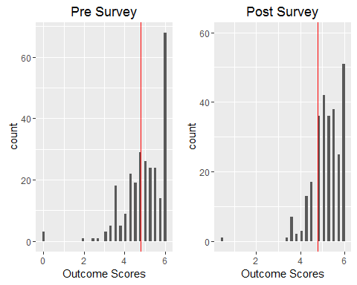

The improvement in outcome scores is graphically represented below.

am_bar_pre <-qplot(am_2016$Pre >=4.8, geom="bar", ylim=c(0, 200), main="Pre survey Results", xlab="Achievment at High Level")  
  
am_bar_post <-qplot(am_2016$Post >=4.8, geom ="bar", main="Post Survey Results", xlab="Achievment at High Level")  
  
grid.arrange(am_bar_pre, am_bar_post, ncol=2)

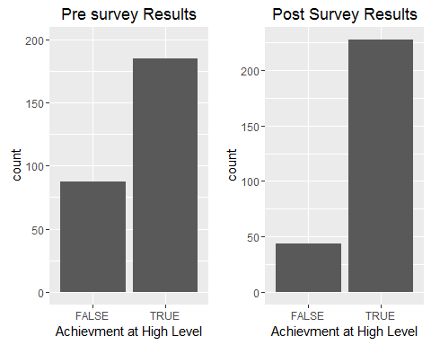

am_change <- am_2016 %>%  
 filter(Pre !=6.0 & Post !=6.0)

The percent of students who went from low achievement to hig achievement is **22.79%** The number of students who had the opportunity to improve their academic engagement outcome score is **174**, and the mean increase in outcome score is **0.4551724**

am_change_p <- ggplot(am_change,(aes(x=am.diff, y=Pre)))  
am_change_p + geom_count() + geom_hline(yintercept = 4.8) + geom_vline(xintercept = 0, col="red") + labs(x="Pre and Post Difference", y="Pre Outcome Score", title="Academic Mastery Survey Results")

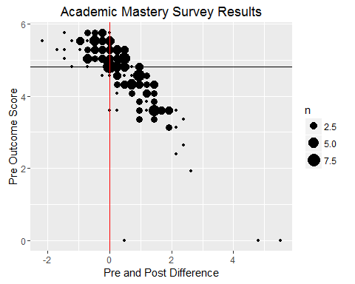

A wilcox.test was administered on the healthy relationship outcome data and the results show that the

pander(wilcox.test(am_2016$Pre, am_2016$Post))

Wilcoxon rank sum test with continuity correction: am_2016$Pre and am_2016$Post

|  |  |  |
| --- | --- | --- |
| Test statistic | P value | Alternative hypothesis |
| 33114 | 0.03277 * | two.sided |

cohen.d(am_2016$Pre, am_2016$Post, paired=TRUE)

##   
## Cohen's d  
##   
## d estimate: -0.2246231 (small)  
## 95 percent confidence interval:  
## inf sup   
## -0.39390858 -0.05533771

## Cross Validation of Academic Mastery

Survey results from teachers and parents also provide evidence that the Get REAL! program helps students formulate better attitude toward school. Below are tables that provide a breakdown of questions on the post survey from the parent and teacher surveys. The pattern again shows improvement in moderate agreement with the question being both with the parent survey and teacher survey.

Parent Survey Question: She has a good attitude about school.Teacher Survey

pre_parent <- dbReadTable(getReal_2016db, "pre_parent")  
  
post_parent <- dbReadTable(getReal_2016db, "post_parent")

pre_parent_tbl <- pre_parent %>%  
 select(12 )  
  
pre_parent_tbl$goodAttitudeAboutSchool <- factor(pre_parent_tbl$goodAttitudeAboutSchool, levels=c("Strongly Disagree", "Disagree", "Slightly Disagree", "Neither Agree/Disagree", "Slightly Agree", "Agree", "Strongly Agree"),ordered = TRUE)  
  
pre_parent_tbl <- likert(pre_parent_tbl)  
  
summary(pre_parent_tbl)

## Item low neutral high mean sd  
## 1 goodAttitudeAboutSchool 0.6437768 2.360515 96.99571 6.51073 0.7957499

post_parent_tbl <- post_parent %>%  
 select(12)  
  
post_parent_tbl$goodAttitudeAboutSchool <- factor(post_parent_tbl$goodAttitudeAboutSchool, levels=c("Strongly Disagree", "Disagree", "Slightly Disagree", "Neither Agree/Disagree", "Slightly Agree", "Agree", "Strongly Agree"),ordered = TRUE)  
  
  
post_parent_tbl <- likert(post_parent_tbl)  
  
summary(post_parent_tbl)

## Item low neutral high mean sd  
## 1 goodAttitudeAboutSchool 1.639344 0.8196721 97.54098 6.463115 0.8281767

Pre Survey

likert.heat.plot(pre_parent_tbl)

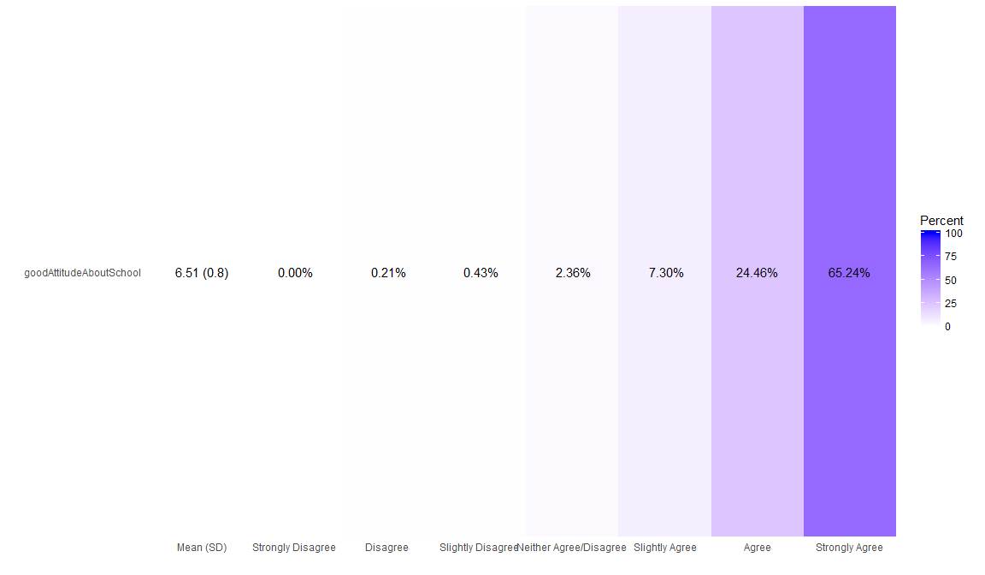

Post Survey

likert.heat.plot(post_parent_tbl)

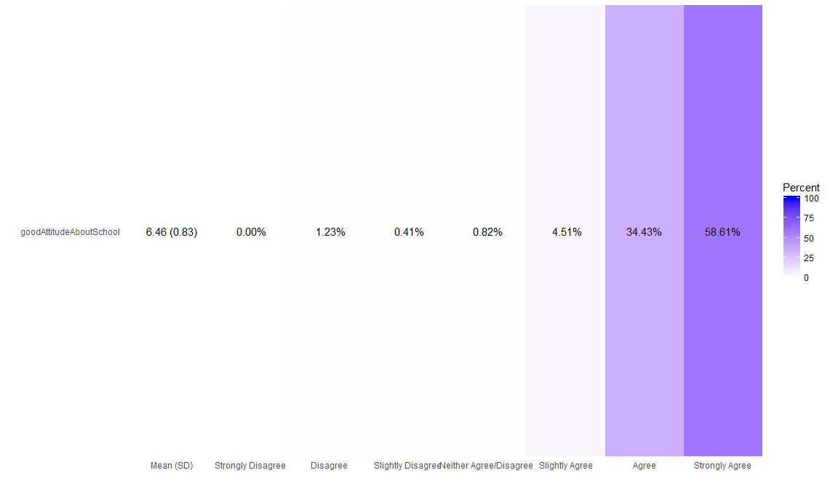

Teacher Survey Question: She has a Good Attitude About School

post_teacher <- dbReadTable(getReal_2016db, "post_teacher")  
  
post_teacher_tbl <- post_teacher %>%  
 select(12)  
  
post_teacher_tbl$goodAttitude <- factor(post_teacher_tbl$goodAttitude, levels=c("Strongly Disagree", "Disagree", "Slightly Disagree", "Neither Agree/Disagree", "Slightly Agree", "Agree", "Strongly Agree"),ordered = TRUE)  
  
  
post_teacher_tbl <- likert(post_teacher_tbl)  
  
summary(post_teacher_tbl)

## Item low neutral high mean sd  
## 1 goodAttitude 0.802139 0 99.19786 6.462567 0.6059932

likert.heat.plot(post_teacher_tbl)

